
QUALITY ALERT

Customer: Golden Date: August 14, 2022
Die: 15603 Colour: WH -141
Type of Complaint: VISION COATING REJECTED

Q.A # Q.I.R # CUSTOMER NCR #

Description: VISION COATING REJECTED Material have some bumpy/moving area at the top surface.
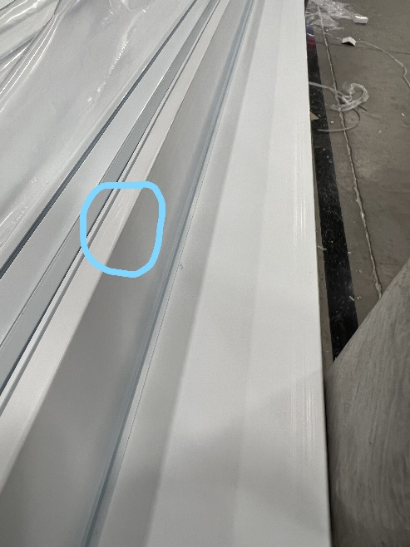
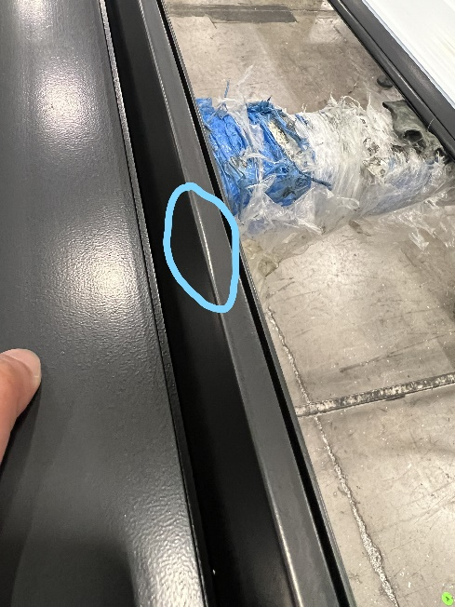

MAKE SURE DO NOT HAVE ANY BUMPY/MOVING ON MATERIAL

BY SIGNING BELOW, YOU ACKNOWLEDGE THE PROBLEM ABOVE AND AGREE TO MONITOR THIS ISSUE IN FUTURE PRODUCTION RUNS.
DAY SHIFT |  | AFTERNOON SHIFT |  | NIGHT SHIFT
NAME | SIGNATURE | NAME | SIGNATURE | NAME | SIGNATURE

